**DYNAMO DB**

Amazon DynamoDB is a serverless NoSQL database service that supports key-value and document data models.

**Features of Dynamo DB:**

* High availability
* Replicas around 3 Availability zones
* Highly scalable
* Stores Key Value pairs
* Fast and consistent in performance
* Security and patching
* Easy to use
* No SQL Database

How to create a table and explore an item in it.

**Step 1: Create Table**

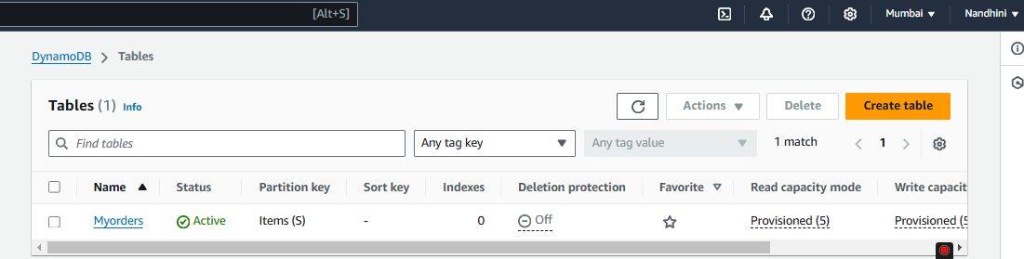

**Step 2: Explore items into the Table**

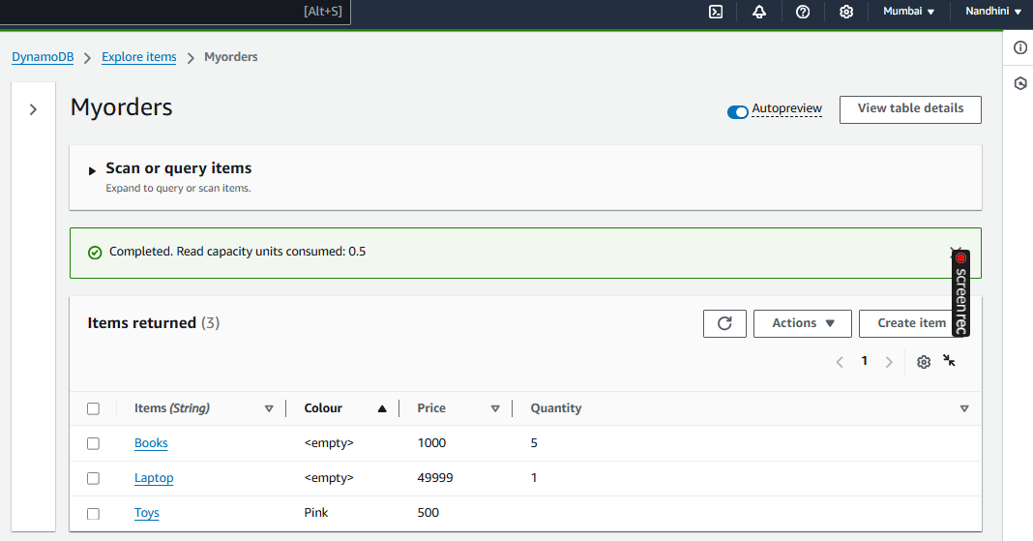

To view a DynamoDB table in an EC2 instance, follow below steps:

Create an EC2 instance:

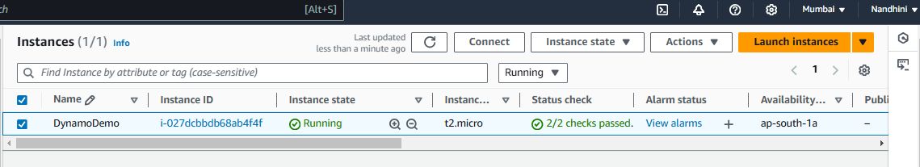

Create a new role with the *AmazonDynamoDBFullAccess* policy.

Attach this role to your EC2 instance.

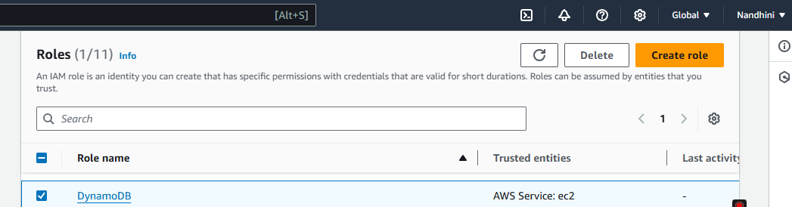

Install *AWS CLI* and configure on the EC2 Instance. Use AWS CLI to Access DynamoDB Table.

